22AIM:-Develop a system using UML for Online Insurance Processing System. The admin can create a category and sub-category, under which a new policy can be added. The user can view and buy the required policies. The system is managed by the Insurance Management System.

USE CASE DIAGRAM:

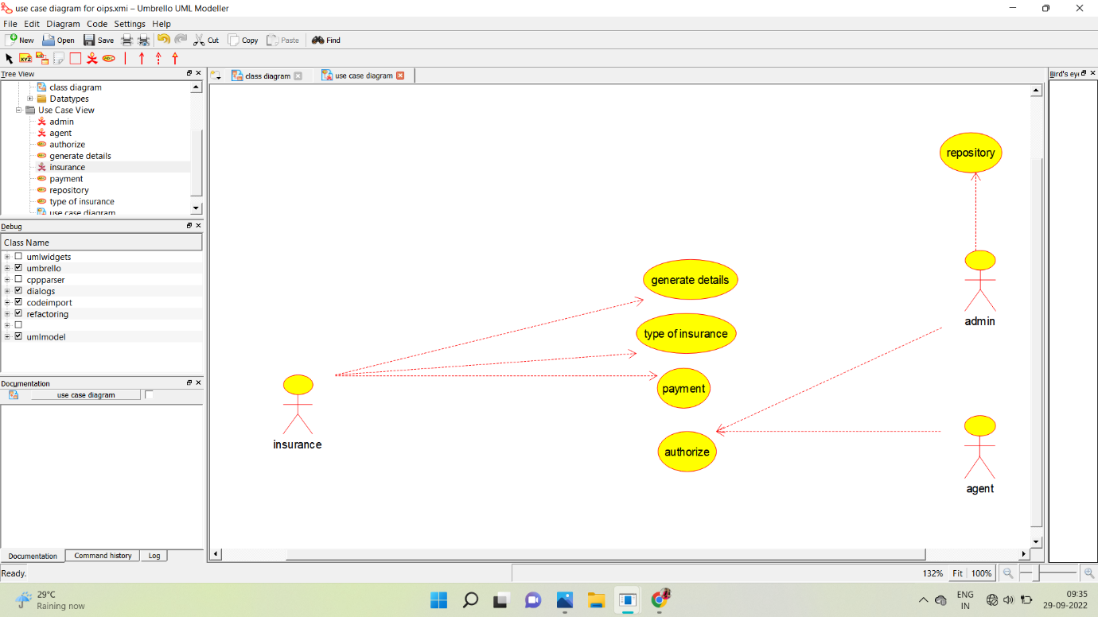

ACTIVITY DIAGRAM: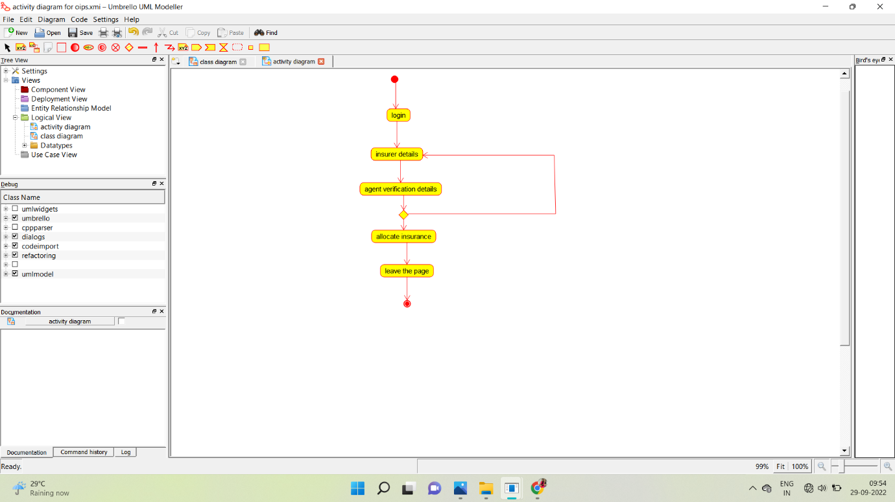

SEQUENCE DIAGRAM:

